WIKIPEDIA-BASED ACTIVITIES AND TRANSLATION COMPETENCE DEVELOPMENT

Małgorzata Kodura
Pedagogical University of Krakow
Abstract
This paper analyses advantages of introducing Wikipedia-based translation activities into translation courses, leading to the development of translation competence among university students, with reference the 2017 EMT competence framework of requirements. It also discusses the approach of the academic world towards Wikipedia as both a source of knowledge and a pedagogical tool, and provides practical examples of Wikipedia-related translation assignments, along with the challenges to be overcome by students, thus leading to the acquisition of skills important in their future careers as professional translators.

Keywords: translation pedagogy, Wikipedia, digital literacy, translation competence, EMT 2017.

- INTRODUCTION

Today, references to Wikipedia in the context of higher education no longer lead to disapproval, although for many years only negative responses were evoked. Wikipedia used to be regarded as a synonym for a low-quality source of knowledge, plagiarism and a lack of objectivism (Santana and Wood, 2009), not worthy to enter lecture halls (Reagle, 2011, p. 17; Jemielniak and Aibar, 2016, p. 1773). In some academic courses, any trace of the presence of Wikipedia in student assignments resulted in immediate disqualification of the paper (Jaschnik, 2007). However, it seems that academics have changed their approach to this globally known source of knowledge, searching for ways to use the vast opportunities it offers as a teaching tool, no longer treating it as an obstacle to appropriate knowledge acquisition (Hick and Howkins, 2015; Minguillón et al., 2018; Dowell and Bridges, 2019; Vetter et al., 2019). This paper describes the application of Wikipedia as a tool supporting translation training at university level, based on experimental activities carried out with various group of translation students. In order to present the many advantages offered by Wikipedia to translation trainers, the focus is on the opportunities to help students develop a broad range of translation competences, with the structure following the 2017 EMT competence framework requirements..

- WIKIPEDIA’S PLACE IN EDUCATION

Wikipedia is one of the top five most frequently visited web services, attracting about 500 million unique visitors each month. Since its establishment in January 2001, about 300 different language versions of Wikipedia have been established, with the original English-language version remaining the largest, featuring over 5.6 million articles. Wikipedia is often defined as an online encyclopaedia provided in an open format, where users can create, amend and/or delete entries and information if they consider it appropriate. From this perspective, Wikipedia represents one of the largest and most recognizable reference resources of current times (Vrandečić 2018, Dowell and Bridges 2019).

Although Wikipedia and universities are both organizations dedicated to the accumulation and dissemination of knowledge, higher education was for long time reluctant to use and to recognise Wikipedia as a valuable teaching tool or to allow the students to use Wikipedia. There are several reasons for this approach. Wikipedia has a reputation for unreliability, since it is written by volunteer contributors, who are not required to provide evidence of their qualifications. Secondly, as anyone can edit the information at any time, there seems to be no guarantee that the information presented is factually correct and/or accurate. There are other objections against using Wikipedia, including the subjectivity of the information it provides or seeing it as a source of plagiarism (Jaschik, 2007; Reagle 2011, pp. 17-18; Turnitin 2013).

At the same time, Wikipedia can be also approached as a concept for inclusive participation, so common on today’s social media platforms, incorporating the idea of online sharing and collaboration (Anari et al., 2013; de Valck et al., 2019). Wikipedia allows users to share and create knowledge in the same way as Internet users share their photographs on Instagram or clips on their You Tube channels, or report their everyday activities on Facebook, i.e. becoming at the same time consumers, participants and producers of the information published on these media. In fact, those aspects of active participation and online collaboration are the most attractive features for educators who are considering the use of Wikipedia in their classroom as an open educational resource, a tool offered free and globally available to all students and teachers.

Despite the initially negative attitude to Wikipedia from academia, the presence of Wikipedia in academic research is growing (Park, 2011; Okoli et al., 2014). It also cannot be denied that it is the most popular reference source on the Web (Knight and Pryke, 2012; Turniton, 2015; Mesgari, 2015; Dowell and Bridges, 2019), and this includes students. As the research by Selwyn and Gerard (2016) shows, more than 87% of students report using Wikipedia. Also, as Head and Eisenberg (2010) demonstrated, over half of the examined students were frequent Wikipedia users even if an instructor advised against it. Students’ use of Wikipedia can be easily observed in any course conducted in a computer laboratory, and this includes translation classes. Since the use of Wikipedia cannot be eliminated from students’ work, academics started to perceive it as a unique opportunity to educate students in Internet-age digital literacy (Okoli et al, 2014; Dowel and Bridges, 2019). By letting students proactively learn how Wikipedia works, including the introduction of the Wikipedia policies of neutral points of view and verifiability, through specifically adapted activities, the teacher can shape the attitude of young people regarding the content and form of online resources.

Wikipedia, as an organization, is aware of its educational potential, in fact it claims to be the single greatest educational resource in the world (Masrour, 2018). In 2010, Wikipedia introduced the Wikipedia Education Program (Wiki Edu) to encourage the academic community to help expand this huge resource. The idea behind the Wikipedia Education Program is simple: educators and students are encouraged to share knowledge, for free, by contributing to Wikipedia and Wikimedia projects in an academic setting, thus helping to improve the quality of the knowledge provided by this resource. The platform provides a comprehensive virtual learning environment plus resources to help teachers and students to initiate projects, in the form of tutorials, start guides and case studies. The courses run with Wikipedia use a platform for monitoring and managing student activities, which is referred to as Dashboard, where the teacher can control deadlines, assignments, traffic statistics, edit counter, etc. This environment is particularly recommended when students are involved in editing articles and/or translation, since on the one hand, it provides useful, real-world translation experience for the students, who will be motivated by the fact that their work will be seen by thousands of Wikipedia readers, and on the other, helps to ensure that Wikipedia articles will be edited in a controlled environment, as a supervised activity (Szymczak, 2013; Joshi, 2019; Wiki Edu).

Wikipedia courses described in the literature concern various fields of study and involve e.g. medical students, who contributed to Wikipedia by improving health-related articles (Azzam et al., 2017), pharmacy students who edited specific pages on medicines as an alternative to writing drug monographs as a classroom assignment (Apollonio, 2018), history students, who contributed to Wikipedia by writing a series of entirely new articles on the history of disability (Blumenthal, 2017), or sociology students improving sociology-related articles (Konieczny, 2012), to mention just a few. The above examples show that students can amend already existing articles, create new ones or become involved in both types of tasks at the same time. This approach can be used as well to improve writing skills (Vetter et al., 2019). Course participants can also contribute media content (which is particularly relevant for students of media studies) (WikiEdu). Finally, the students’ contribution can take the form of the translation of already existing articles in other languages, which is an especially important activity from the perspective of translation trainers.

Translation courses involving Wikipedia assignments and also larger projects have been described in the literature, for instance with regard to courses involving Arabic (Al-Shehari, 2017), Spanish (Calzada and Navarro, 2013), Polish (Szymczak, 2013), or those that are multilingual (Alonso et al., 2018). An extensive list of Wikipedia translation projects is available at the Wikimedia UK site (Teaching Translation via Wikipedia). The advantages of the activities enumerated by the above cited teacher-researchers mainly focus on the usefulness of the translations, the novelty of the translation exercises as compared to typical translation tasks and the increased level of student satisfaction with their assignments, resulting from the opportunity to show their work to others, to make a contribution to the most popular online encyclopaedia and to receive feedback from a broader audience, and not only their teacher.

Wikipedia-based assignments are reported to increase student involvement and satisfaction with the translation course due to working on genuine tasks, which certainly has an impact on their learning process, following Kiraly’s (2000) social constructivist approach. However, it has not been discussed whether such activities have any direct effects on the acquisition of translation competence by translation students, i.e. whether it is a tool to be used by trainers to develop the individual sub-competences of translator trainees. This question will be investigated in detail in the next part of the paper, and measured against the latest competence framework for translation graduates, namely the 2017 EMT standards. Wikipedia assignments, as well as the various individual and group tasks described below, are based on the experience of the author of the article while conducting Wikipedia-based courses and activities over four semesters at the Institute of Modern Languages of the Pedagogical University in Cracow. The courses were held during the academic years 2017/2018 and 2018/2019, and were for masters degree students following the translation specialisation in the English Philology programme. Two courses were entirely based and graded upon translation of Wikipedia articles, while in the other two courses, Wikipedia activities were used as extra assignments in addition to other tasks related to translation technology and tools. The students were asked to translate three articles (350-500 words) individually, and also two articles in small groups of 3-4 people. The students primarily worked at home, or online within their group, while class meetings were used for solving technical problems and discussions on particular translation strategies, as described below. The first class was devoted to instructions on how to set up an account on the Wikipedia platform (which simply involves creating a username and a password, while e-mail addresses are optional and only required for resetting forgotten passwords) and how to become a member of a virtual class on the Wikipedia Dashboard course set up by the teacher. It was clearly stated at the beginning that it was not compulsory for the students to publish articles on the official, online version of the platform and unpublished translations would be also accepted by the teacher, since Wikipedia is a volunteer service. Nevertheless, the possibility of publishing their texts was extremely tempting, and the majority worked towards an online version, especially when they learnt that after making as few as 10 edits or having an account for at least 4 days, they were able to move the article from their sandbox to the main Wikipedia space. The division of roles in the groups was the students’ responsibility, which they presented and justified in their final report, submitted at the end of the semester in the form of a translator’s commentary. Additionally, the students were asked to complete an evaluation survey concerning student learning related to the Wikipedia-based translation course, the results of which are to be presented in a separate paper (Kodura, 2018).

- TRANSLATION COMPETENCE ACQUISITION THROUGH WIKIPEDIA-BASED ASSIGNMENTS

Translation competence is not only a very complex term, but it also is a very changeable one. Without doubt, apart from learning how to render a text from the source language to the target language, a translator who wants to compete in the current market must also master other sub-competences. Technology and social demands have ensured changes in translator competence over time, which can be easily observed when analysing the market demands and qualifications required from a professional translator (Pietrzak, 2015, p. 317). Therefore, it is not surprising that new models of translation competence emerge, to keep pace with the changing market situation. One of the most popular translation competence models is that of the PACTE research group (2003), consisting of five sub-competencies: bilingual sub-competence, extra-linguistic sub-competence, knowledge about translation sub-competence, instrumental sub-competence and strategic sub-competence, with the latter being fundamental. Another model, also referred to as the EMT “Wheel of Competence” was created by the EMT Expert Group (2009), working on the European Master Program in Translation, and includes six categories: language competence, intercultural competence, info mining competence, technological competence, thematic competence and translation service provision competence. A model of translation competence acquisition presented by Göpferich (2009) is even more complex, as it additionally includes motivation, psycho-motor competence and translation routine activation competence, and takes into account three factors that form the basis of the model, namely the translation brief and translation norms, the translator’s self-concept/professional ethos and the translator’s psycho-physical disposition (intelligence, ambition, perseverance, self-confidence, etc.). The models themselves also develop over time, e.g. the current EMT translation competence model (2017) is structured along slightly different sets of sub-competences, reflecting the changes that occurred in the last decade to ensure that competences of translation programme graduates match the requirements of their future employers and defines five areas of competence: language and culture, translation, technology, personal and interpersonal competence and services provision. The model is no longer presented as a wheel, but instead resembles a well-organized machine, in which all the gears are necessary to drive the progress.

Figure 1. EMT Translation Competence Model 2017
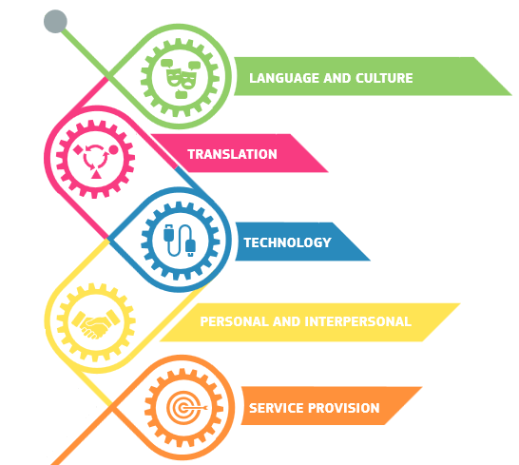

It should be mentioned at this point that the EMT competence model is not only a theoretical approach, but is actually a set of requirements for translation training institutions who want to join the EMT network with the aim of improving the standard of translation training within the European Union and facilitating cooperation between academic institutions offering translation programmes (EUATC). In this paper, the areas in which Wikipedia-based activities can contribute to developing the translator competence of translation trainees are organized to follow the structure of the 2017 EMT requirement framework, and to show the potential of these types of activities in developing various areas of translation competence.
  - Language and culture
Although it cannot be argued that the activities based on Wikipedia provide a comprehensive tool answering all the requirements of university translation programmes, the teacher can always focus on those aspects that are actually needed for future translators, regardless of the type of texts. This is difficult in the area of language and culture, which encompasses general or language-specific linguistic, sociolinguistic, cultural and transcultural knowledge, as in the main translation classes are not directed towards language learning, yet some improvement in this domain can be achieved in a Wikipedia-based course. The fact-oriented language used in Wikipedia is not very sophisticated, as its purpose is to provide clear information, therefore students typically are not challenged to learn new words, idioms or structures (Szymczak, 2013, p. 67; Kodura, 2018). Nevertheless, what is beneficial for translation students in the area of language is the improvement of their native language. Translation students who participated in Wikipedia-based courses at the Pedagogical University in Cracow found it difficult to express themselves in Polish and to follow the so-called “dry” style of Wikipedia. Therefore, as one of the first assignments, they were asked to look at articles in Polish that needed language improvement (a special category of tasks for beginner Wikipedians – “Fix spelling and grammar”). At the same time, as it was their first attempt at Wikipedia editing, it also helped them to improve their revision skills. The students found this even more challenging than when completing similar tasks in the English language version of the Wikipedia Community Portal. As regards the directionality of translation, the students were mostly encouraged to develop the Polish Wikipedia by translating articles in English, although in some cases the students undertook translation of articles on Polish history, culture and customs into English (e.g. on the Greek-style fish eaten on Christmas Eve in Poland). This helped the students to expand their cultural and transcultural knowledge, but also to improve their language competence, since the translated articles were addressed to English-speaking readers and sometimes required linguistic revision of the work of native speakers of English. This renders Wikipedia projects particularly fit for international cooperation, such as the Trans-Atlantic & Pacific Projects, in which students from one country collaborate with students from another country by translating and revising translated texts (Maylath et al., 2008). Although such a bilateral partnership has not been established by the institution described in this article, plans are underway to enter the project, thus improving the linguistic competence of Polish translation students and the revision skills of English-speaking students, based on the assumption that the peer feedback facilitates acquisition of required skills (Lisaitė et al., 2015).
  - Translation
The EMT framework defines its area of translation competence as not only the actual transfer of meaning between two languages, but also all the strategic, methodological and thematic competences that are required before, during and after the transfer phase (EMT Competence Framework, 2017). In this area Wikipedia-based assignments could help to develop methodological competence, as the students must acquire and develop domain-specific knowledge related to the actual article they are translating. Since they are required to use appropriate terminology and phraseology, the students must use specialised sources to gain this knowledge. When translating articles in Wikipedia, the students were advised to follow all the sources linked below the article, to acquire a better insight into the content of the article, and gain thematic competence, to view images and to undertake research in Polish to find the appropriate terminology in the articles published online on the same topic (e.g. in an article on machine translation of sign languages). Moreover, they were also encouraged to provide Polish references for the Wikipedia articles translated into Polish, which ensured they learnt the appropriate terminology, and used the chosen word correctly.

Such activities, oriented towards searching for appropriate vocabulary in a domain-specific text help to develop in the students the habit of double-checking the vocabulary they use in their translation, which is not always the case in “classic” classroom translation, where the use of an incorrect word does not result in anything more than a lower grade for an assignment. The awareness of a wider audience reading the translation online makes the students more careful in their word choice. Additionally, and this is a good lesson for their future professional life, the students were hesitant to translate articles on subjects they were not familiar with, preferring to rely on their own personal experience and knowledge to translate articles related to their hobbies, studies or personal experience (e.g. a student who used to be a professional swimmer translated articles on two American swimmers, Ella Eastin and Kathleen Hersey).

Within the area of EMT translation competence, translation graduates should be also able to implement the instructions and style guides relevant to a particular translation, a skill which is also necessary in the Wikipedia activities. Before starting the actual translation, the students were asked to acquaint themselves with the Wikipedia Manual of Style, which can be found on its Community portal. Although an encyclopaedia style is not difficult to follow, it is not the language that the students of English Philology are taught to use in their writing classes, therefore, they had to pay particular attention to all the language requirements, especially with regard to tenses, sentence structure and the absence of figurative language. A useful exercise that helps the students to follow the required style is to ask them to improve the articles marked as “Requiring improvement” on the Wikipedia Community portal (“Improve style” tasks).
The translation category of learning outcomes also requires the ability to analyse and justify the translation solutions and choices. The development of this sub-competence is facilitated by the Wikipedia feature of discussion (“Talk” page) that accompanies each article, e.g. the issue of whether to translate into Polish the names of the members of the British Royal Family. Another translation problem worth mentioning was related to the article on the Me Too movement and the discussion as to whether to translate its title, as it is sometimes but not frequently, used in the Polish media, or to leave it in the original form. Other students, not directly involved in this article, were also asked to give their opinion on this translation problem, which improved their ability to assess the pros and cons of each translation decision made. In several articles, young translators who disagreed with the changes introduced by other users (other students or other Wikipedians, after the article was published) were obliged to explain and defend their choices, if they wanted their version to remain. Translation choices could be explained and defended at least at two stages: before the publication, that is in the draft version of the article, when different variants and justifications could be seen in the editing history and also in the talk page of an article in the sandbox. As was specified above in the description of the project, the students mainly worked online, while class activities were intended to address and solve possible technical, linguistic or translation problems, as well as acting as a forum for discussion of questionable translation choices. Changes were introduced immediately in an online mode, and the editing history clearly showed who was responsible and when a given solution was suggested. The situation was slightly different in articles already published, when instead of simply introducing changes, the students had to argue why they preferred their version by writing their arguments on the Talk page. The entire process involved an important sub-competence mentioned in the EMT framework, namely the ability to check, review and/or revise their own work and that of others. The students’ work on Wikipedia articles always involved the stage of checking and revising, as they either worked in groups or had their draft versions revised by their classmates. Unsurprisingly – as a similar issue is often observed in “standard” translation courses – the students found it more difficult to check the work of others than to translate on their own, especially that their revisions were also visible online (in the “View history” tab) and could always be reversed. Additionally, in the Wikipedia-based course the students had to understand another type of revision, also mentioned in the EMT requirements, namely post-editing machine translation output. The students, who were encouraged to use the Content Translation tool, a beta feature providing a framework for translating pages from one language to another, also had access to the MT embedded in the tool, which in the case of the Polish language was the Yandex MT engine. For many course participants it was their first encounter with MT output, that is apart from Google Translate which is familiar to most students. As Yandex only suggested certain translation solutions, the students had the option to use the suggestion, to turn off the suggestions or to improve on what was suggested, thus practicing decision-making skills. This helped them to evaluate the solutions offered by MT and to assess the relevance of MT systems in translation workflow (the sub-competence mentioned in the Technology area of EMT 2017).

  - Technology
Wikipedia-based translation activities provide a perfect response to the technology aspect of EMT requirements. Although students today are thought to be “digital natives,” they are not yet “digital citizens” (Blumenthal, 2017). They regularly interact on social media, but usually they are not concerned by the technology or engineering behind their activity, and the type of assignments described in this paper can help them develop and master digital literacy skills. In this regard, Wikipedia-based courses can be used as a practical solution in the technology-mediated approach, i.e. an approach where technologies, not necessarily specific to translation practice, are not regarded as isolated tools, but as instruments to develop further actions (Alonso and Calvo, 2015), thus increasing the necessity for students to develop digital literacy skills. Wikipedia translations require students to use and rapidly adapt to new tools, e.g. the above-mentioned Content Translation application, equipped with features resembling the CAT tool environment, as presented in Figure 2 below.

Figure 2. A print screen from the Content translation tool
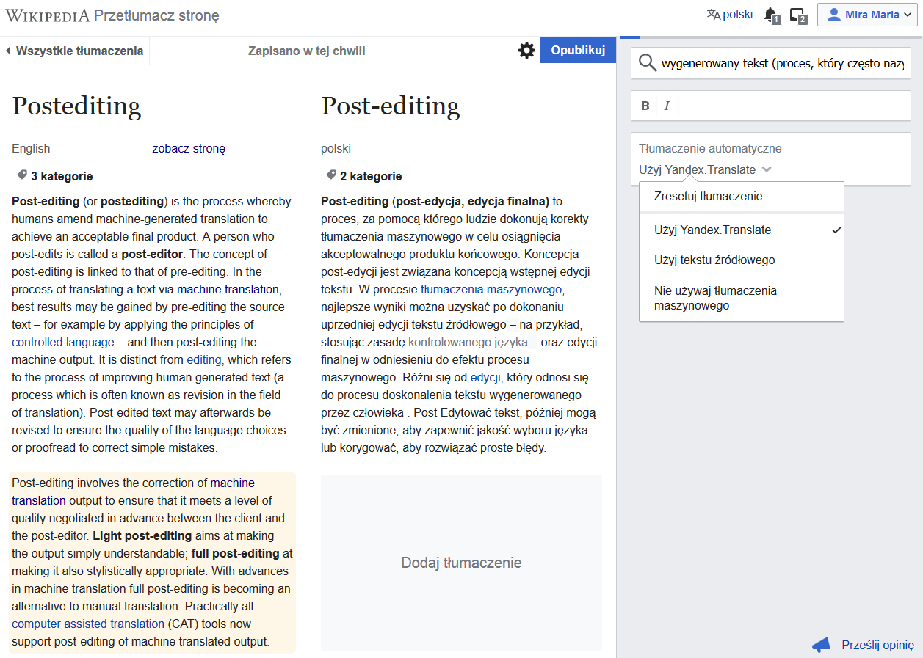

Students translating Wikipedia articles are also required to learn the Wiki markup code and selected HTML elements, as well as the wiki working mechanisms, in order to use the web technologies mentioned in the EMT requirements. The students’ assignments are not limited to a translation of the text, as their articles must be correctly structured (with the use of the Wikicode) and be equipped with valid links to the references. Working with Wikipedia articles involves working in an unfamiliar environment and mastering elements of programming, as presented in Figure 3 below. Although images, infoboxes, categories and tables of content are not necessary for an article to be published, the students often made an additional effort to learn the technical side and to publish their articles in the full format, linking them to the source language version of the article. The students had to acquire the necessary information and skills thorough independent work, reading instructions, using Help Desk articles, following and participating in Wikipedia maintenance discussions and asking more experienced Wikipedians for advice and assistance. This certainly helped them to become more active online participants in a virtual community, so typical of present-day translation work and online collaboration, which is also directly linked to the next area of competence to be described in the following subsection.

Figure 3 A print screen of source code editing in the user’s sandbox
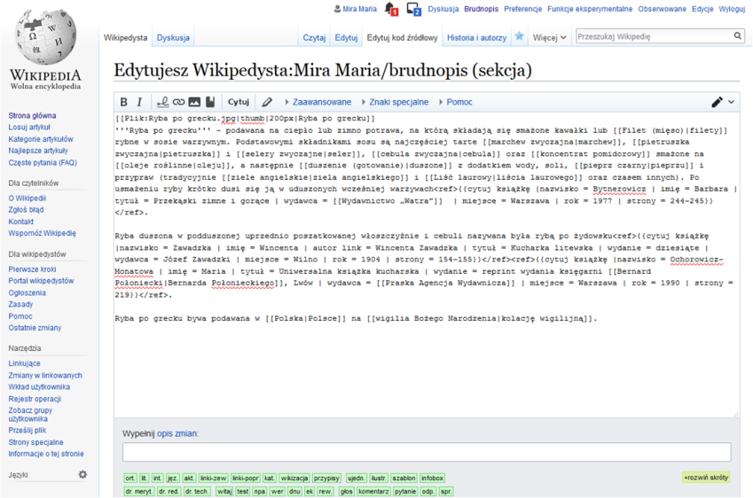

  - Personal and interpersonal competence
With regard to the personal and interpersonal competence requirements, as mentioned above the students had to learn to collaborate online, both with people they knew (classmates) and with other online users (Wikipedia administrators and other Wikipedians). They practiced using online technologies for professional (translation-related) purposes and became acquainted with the dispute resolution procedure and the instructions offered by Wikipedia (“Staying cool when the editing gets hot”). The young translators had to learn to work in a team in the virtual environment, using modern communication technologies, which in the case of Wikipedia is the discussion (“Talk”) page. The only translation format used by the students was the Wikipedia drafts (the user’s sandboxes) or published articles. By working online, the students had to learn and follow online etiquette, an essential skill in today’s work environment, participating at the same time in a large-scale (global) project. The students were not required to use their full name as Wikipedia logins/usernames, and actually most used imaginative nicknames (thus our course additionally involved elements of gaming, a popular trend in contemporary education). The students were not completely anonymous, however, as they were linked to our university translation project, which also was mentioned on their user pages. After achieving a certain numbers of edits, they gained subsequent levels of Wikipedia membership, giving them more rights to address Wikipedia tasks, such as moving a draft to the mainspace without the assistance of an administrator.

As outlined in the EMT requirements, translation trainees should plan and manage the time of their work, with all their progress visible to the teacher and the other project participants who knew the link to individual students’ sandboxes, and later, after the publication of an article, to all Wikipedia users. The students working in groups had to manage their workload, as again their individual contribution to group projects could be monitored in the “View history” or “Contributions” tabs. In an article completed during a single two-hour lesson by the entire class (Invictus Games), the students could immediately see the contribution and effort of the other team members. The students had to take responsibility for their own tasks, and had to overcome their reluctance to show their work when it was still in progress, which actually improved their team-working skills.
  - Service provision
According to the EMT requirements, the service provision competence covers all the skills related to the implementation of a translation, from client awareness to project management and quality assurance (EMT 2017, p. 11). In the case of Wikipedia-based translation activities, it involved being open to suggestions, to understanding and implementing the style and content instructions and to carefully revising the final drafts, bearing in mind the end user, which in this case was the wider public audience. The students had to learn and follow the ethical standards imposed by Wikipedia, e.g. how to use reliable sources. Even though Wikipedia is a free online resource, its contributors must be aware of and follow certain copyright and licence rules, as well as realizing the importance of contribution, e.g. when uploading non-free content images onto the translated articles, content images whose licences allowed them to be published on the English language version, the students discovered that such images were immediately deleted by the administrators from the Polish version as it is illegal to use an image from a different language version (this occurred in an article about a Japanese manga superhero series). Working with Wikipedia helped the students to develop a greater awareness with regard to the reliability of the sources used in their work, especially after they realized that the title of an article depends solely on their own decisions, since before the course, they tended to switch between Wikipedia language versions to check the “official” translations. Finally, the students learned how to provide references for any factual information provided in Wikipedia and consequently, how to verify information published online. It would be hoped that this ability will help them in their professional practice as translators, accountable for their own work.

- CONCLUSIONS

Wikipedia offers an open, globally recognized resource that can be used by translation trainers as a library of source texts, as a tool and as translation environment, at no cost. In view of the fact that it offers multiple forms of working modes (individual work, online collaboration, group activities), it provides a versatile platform for translation practice (including e-learning and international projects). Additionally, it is an attractive form of translation practice for students, allowing them to immerse themselves into genuine translation tasks, learn through practice, and enjoy a sense of accomplishment through the meaningfulness of their translation work. However, it is a constantly changing environment, and platform options available to today’s students and teachers may change in the future or be replaced with new ones, offering different opportunities, especially with regard to the features offered today as beta functions (Content Translation), which may evolve or be entirely dropped. Working with Wikipedia requires that the teacher is up to date with the latest changes, adjusting the Wikipedia activities to what is currently available. Last but not least, it should be borne in mind that such activities require the appropriate equipment (computers) and a stable Internet connection. An Internet failure could clearly destroy carefully planned Wikipedia-based class activities. Nevertheless, as can be seen from the areas of translator competence discussed above that can be developed through the use of Wikipedia translation tasks, such activities might provide a highly valuable option for translation trainers conducting courses at university level with a focus on the translation competence standards to be achieved by their graduates.

REFERENCES

Al-Shehari, K. (2017). Collaborative learning: trainee translators tasked to translate Wikipedia entries from English into Arabic. The Interpreter and Translator Trainer, 11(4), 357–372.

Alonso, E. & Calvo, E. (2015). Developing a blueprint for a technology-mediated approach to translation studies. Meta, 60(1), 135–157.

Alonso, E., Briales, I. & Filsinger, G. (2018). Esto necesito y así lo soluciono: necesidades y herramientas de estudiantes y profesionales de la traducción y la interpretación frente al reto multilingüe digital. Tradumàtica, (16), 1-23.

Anari, F. Asemi, A., Asemi, A. & Munir, A. B. (2013). Social Interactive Media Tools and Knowledge Sharing: A Case Study. ArXiv, abs/1309.1825.

Apollonio, D. E., Broyde, K., Azzam, A., De Guia, M., Heilman, J., & Brock, T. (2018). Pharmacy students can improve access to quality medicines information by editing Wikipedia articles. BMC Medical Education, 18 (1), 265.

Azzam, A., Bresler, D., Leon, A., Maggio, L., Whitaker, E., Heilman, J., Orlowitz J, Swisher, V., Rasberry, L., Otoide, K., Trotter, F., Ross, W., McCue, JD. (2017).Why Medical Schools Should Embrace Wikipedia: Final-Year Medical Student Contributions to Wikipedia Articles for Academic Credit at One School. Acad Med, 92 (2), 194-200.

Blumenthal, H. (2017). Teaching History with Wikipedia, WikiEdu. Retrieved June 17, 2019, from https://wikiedu.org/blog/2017/05/24/teaching-history-with-wikipedia/.

Calzada, M. & Navarro, S. (2013). Aprendices de la traducción con Wikipedia. Paper presented at the International Seminar Wikipedia and University: Research and Teaching Experiences, Barcelona. Retrieved June 16, 2018, from http://oer.uoc.edu/wiki4HE/seminari-internacional/presentacions/.

de Valck, K., van Bruggen, G. & Wierenga, B., (2009). Virtual communities: a marketing perspective. Decision Support Systems, 47 (3), 185-203.

Dowell, M. L. & Bridges, L. M. (2019) A Perspective on Wikipedia: Your Students Are Here, Why Aren’t You? The Journal of Academic Librarianship, 45 (2), 81-83.

EMT Expert Group (2009). Competences for professional translators, experts in multilingual and multimedia communication. Retrieved November 5, 2015, from http://ec.europa.eu/dgs/translation/programmes/emt/key_documents/emt_competences_translators_en.pdf.

EMT competence framework (2017). Retrieved May 3, 2018 from https://ec.europa.eu/info/sites/info/files/emt_competence_fwk_2017_en_web.pdf.

EUATC [European Union of Association of Translation Companies], European Master’s in Translation (EMT) project. Retrieved June 10, 2019, from https://www.euatc.org/news/item/162-european-masters-in-translation-emt-project.

Göpferich, S. (2009). Towards a model of translation competence and its acquisition: The longitudinal study TransComp. In Göpferich, S., Jakobsen, A. L. & Mees I. M. (Eds.), Behind the mind: methods, models, and results in translation process research (pp. 11-37). Copenhagen: Samfundslitteratur.

Head, A. J. & Eisenberg, M. B. (2010). How today’s college students use Wikipedia for course–related research. First Monday, 15 (3), retrieved June 15, 2019, from https://firstmonday.org/ojs/index.php/fm/article/view/2830/2476.
Hicks, A., Howkins, A. (2015). Tipping the Iceberg: A Collaborative Librarian-Historian Approach to Redesigning the Undergraduate Research Assignment. The History Teacher 48 (2), 339-370.

Jaschnik, S. (2007). A Stand Against Wikipedia. Inside Higher Ed, 26 January 2007. Retrieved 5 October 2019 from https://www.insidehighered.com/news/2007/01/26/stand-against-wikipedia.

Jemielniak, D., Aibar E. (2016). Bridging the Gap Between Wikipedia and Academia. Journal of the Association for Information Science and Technology 67 (7),1773–1776.

Joshi, M, Verduzco, R, Yogi, S, Garcia, M, Saxena, S., Tackett, S., Dexter, N., Dempsey, A., Whitaker, E., Azzam, A. (2019). Wikipedia Editing Courses at Three US Medical Schools in the 2017-2018 Academic Year. MedEdPublish, 8 (2) https://doi.org/10.15694/mep.2019.000146.1

Kiraly, D. (2000). A Social Constructivist Approach to Translator Education; Empowerment from Theory to Practice, Manchester, UK & Northampton MA: St. Jerome Publishing.
Knight, C., Pryke, S. (2012). Wikipedia and the University, a case study. Teaching in Higher Education, 17 (6), 649-659.

Kodura, M. (2018). Wikipedia translations as a tool in translator education –the students’ perspective. Paper presented at the Fourth International Conference on Research into Didactics of Translation, Universitat Autònoma de Barcelona.

Konieczny, P. (2012). Wikis and Wikipedia as a teaching tool: Five years later. First Monday, 17 (9). Retrieved August 18, 2019, from https://firstmonday.org/ojs/index.php/fm/article/view/3583/3313.

Lisaitè, D., Vandepitte, S., Maylath, B., Mousten, B., Castel-branco, M. C. A. E. & Minacori, P. (2016). Negotiating meaning at a distance: Peer feedback in electronic learning translation environments. In M. Thelen, G-W. van Egdom, D. Verbeeck, Ł. Bogucki & B. Lewandowska-Tomaszczyk (Eds.) Translation and Meaning (pp. 99-116). Berlin: Peter Lang.

Masrour, V. (2018). Wikipedia as a toolset for Open Education. Paper presented at Open Education Global Conference, Technische Universiteit Delft. Retrieved on October 10, 2019 from https://upload.wikimedia.org/wikipedia/commons/2/2b/Wikipedia_as_a_toolset_for_Open_Education_publish.pdf.

Mesgari, M., Okoli, C., Mehdi, M., Nielsen, F. A. & Lanamäki, A. (2015). The sum of all human knowledge: A systematic review of scholarly research on the content of Wikipedia. Journal of the Association for Information Science & Technology, 66 (2), 219-245.

Minguillón, J., Aibar, E., Lerga, M., Lladós-Masllorens, J. & Meseguer-Artola, A. (2018). Wikipedia in academia as a teaching tool: from averse to proactive faculty profiles. Retrieved on October 10 from https://www.researchgate.net/publication/322652787_Wikipedia_in_academia_as_a_teaching_tool_from_averse_to_proactive_faculty_profiles

Maylath, B., Vandepitte, S., & Mousten, B. (2008). Growing Grassroots Partnerships: Trans-Atlantic Collaboration between American Instructors and Students of Technical Writing and European Instructors and Students of Translation. In D. Starke-Meyerring & M. Wilson (Eds.), Designing Globally Networked Learning Environments: Visionary Partnerships, Policies, and Pedagogies (pp. 59-66). Rotterdam: Brill.
Okoli, C., Mehdi, M., Mesgari, M., Nielsen, F. Å., & Lanamäki, A. (2014). Wikipedia in the eyes of its beholders: A systematic review of scholarly research on Wikipedia readers and readership. Journal of the Association for Information Science and Technology, 65 (12), 2381-2403.

PACTE (2005). Investigating translation competence. Conceptual and methodological issues, Meta, 50 (2), 609–19.

Park, T. K. (2011). The visibility of Wikipedia in scholarly publications, First Monday, 16 (8). Retrieved October 10 2019, from https://firstmonday.org/ojs/index.php/fm/article/view/3492/3031.

Pietrzak, P. (2015). Translation competence. In Ł. Bogucki, S. Góźdź-Roszkowski & P. Stalmaszczyk (Eds.), Ways to Translation (pp. 317–338). Łódź-Kraków: Łódź University Press & Jagiellonian University Press.

Reagle, J. (2011). The Argument Engine, In G. Lovink, N. Tkacz (Eds.), Critical Point of View: A Wikipedia Reader (pp. 14-33). Amsterdam: Institute of Network Cultures.

Santana, A., Wood, D. J. (2009). Transparency and social responsibility issues for Wikipedia. Ethics and Information Technology, 11 (2), 133-144.

Selwyn, N. & Gorard, S. (2016). Students’ use of Wikipedia as an academic resource – Patterns of use and perceptions of usefulness. The Internet and Higher Education, 28, 28–34.

Szymczak, P. (2013). Translating Wikipedia Articles: A Preliminary Report on Authentic Translation Projects in Formal Translator Training. Acta Philologica, 44, 61–70.

Teaching Translation via Wikipedia. Retrieved May 10, 2019, from https://wikimedia.org.uk/wiki/Teaching_Translation_via_Wikipedia.

Turnitin (2013). The Sources in Student Writing – Higher Education. Sources of Matched Content and Plagiarism in Student Writing. White Paper. Oakland: iParadigms, LLC. Retrieved October 10, 2019 from https://library.wwu.edu/files/wis_tla/Turnitin_WhitePaper_Sources_in_Student_Writing_HE.pdf

Turnitin (2015). What’s Wrong with Wikipedia? Evaluating the Sources Used by Students. White Paper. Oakland: iParadigms, LLC. Retrieved October 10, 2019 from http://www.siue.edu/its/turnitin/pdf/Turnitin_WhitePaper_EvaluatingSources.pdf.

Vetter, M., McDowell, Z. J., Stewart, M. (2019). From opportunities to outcomes: The Wikipedia-based Writing Assignment. Computers and Composition, 52, 53–64.

Vrandečić, D. (2018). Toward an abstract Wikipedia Description Logics. In M. Ortiz & T. Schneider (Eds.), Proceedings of the 31st International Workshop on Description Logics. Retrieved October 10, 2019, from http://ceur-ws.org/Vol-2211/paper-03.pdf

WikiEdu [Wiki Education Foundation]. Wiki Education Dashboard. Retrieved on June 10, 2019 from https://dashboard.wikiedu.org.

